**Q.1 What is jQuery?**

**Ans:** jQuery is a small, light-weight and fast JavaScript library. It is cross-platform and supports different types of browsers. It is also referred as ? write less do more? because it takes a lot of common tasks that requires many lines of JavaScript code to accomplish, and binds them into methods that can be called with a single line of code whenever needed. It is also very useful to simplify a lot of the complicated things from JavaScript, like AJAX calls and DOM manipulation.

**Q.2 How to Apply CSS Using JQuery, How to Add Class and Remove Class in Jquery , JQuery Animation?**

**Ans:** **To apply CSS using jQuery :**

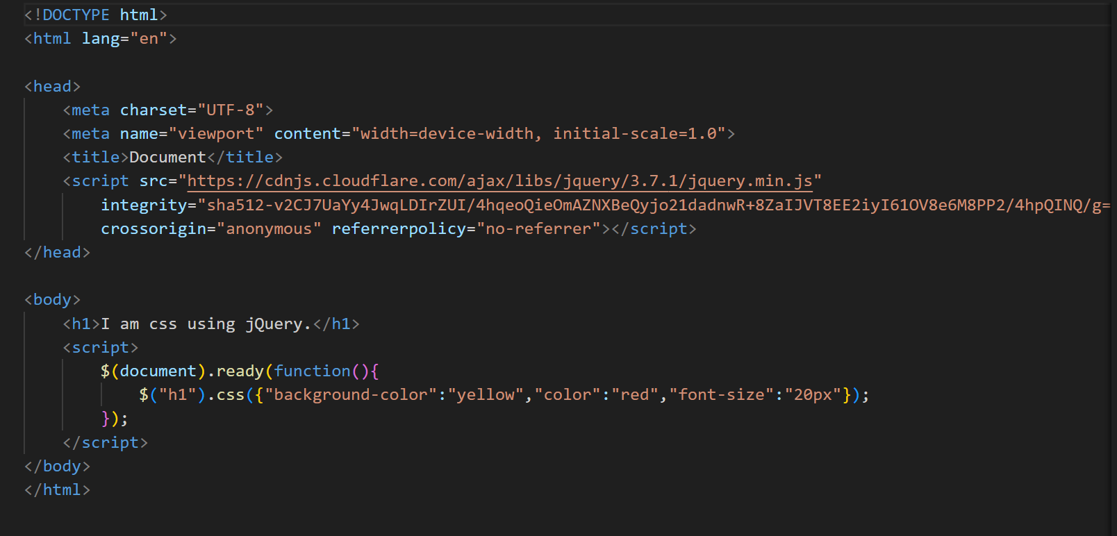

**Output:**

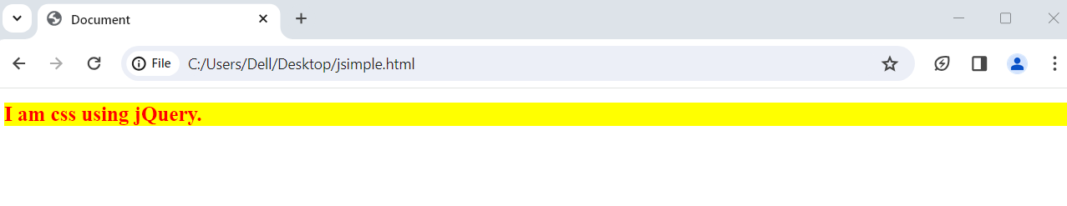

**Add class and Remove class :**

The addClass() method adds one or more class names to the selected elements.

This method does not remove existing class attributes, it only adds one or more class names to the class attribute.

**Syntax:**

$(*selector*).addClass(*classname*,function(*index,currentclass*))

Required. Specifies one or more class names to be added

| **PARAMETER** | **DEFINITION** |
| --- | --- |
| classname | Required.Specific one or more class names to be added. |
| function(*index,currentclass*) | Optional. Specifies a function that returns one or more class names to be added   * *index* - Returns the index position of the element in the set * *currentclass* - Returns the current class name of the selected element |

Example:

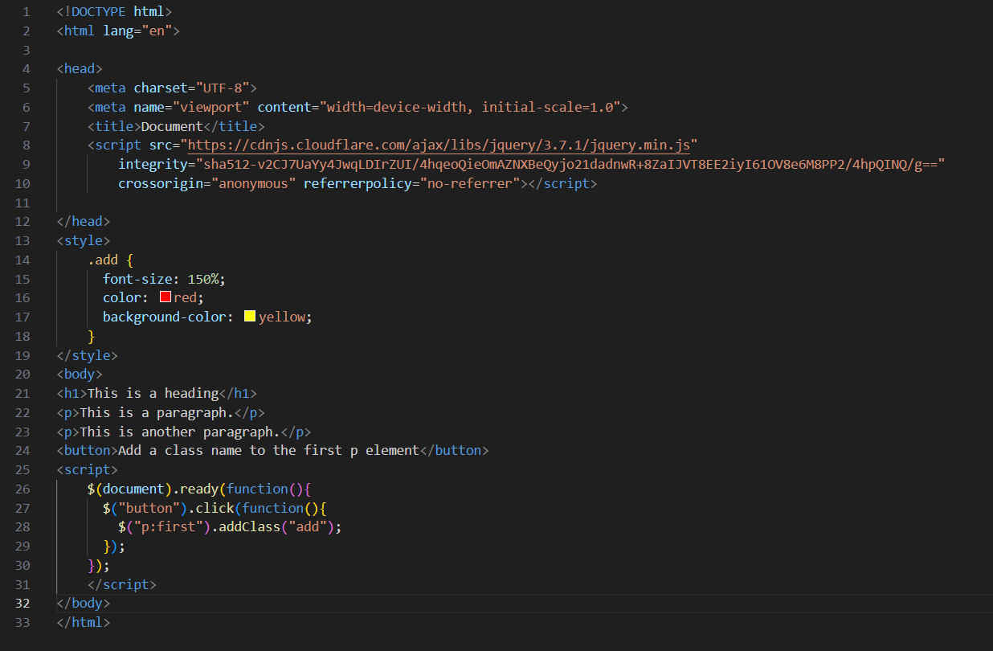

Output :

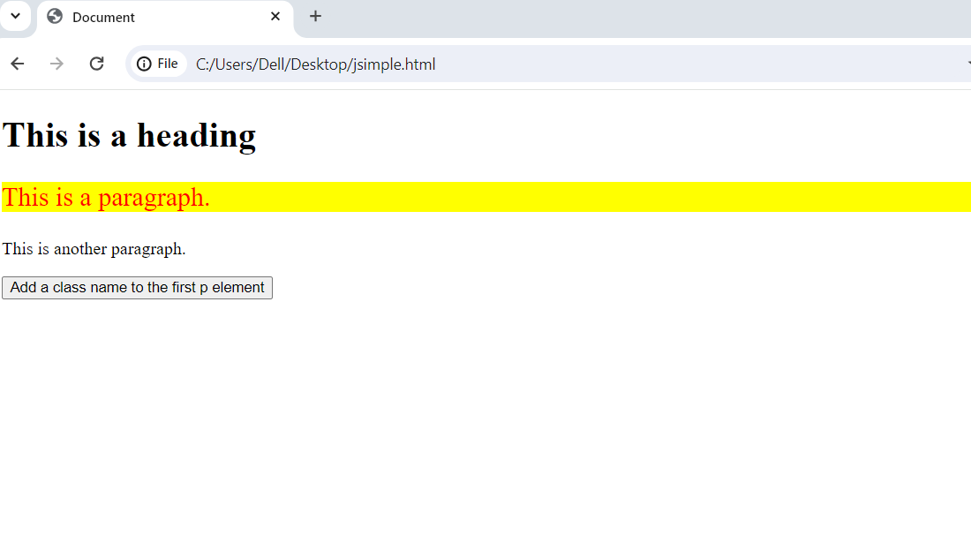

**Remove class:**

The removeClass() method removes one or more class names from the selected elements.

Syntax: $(*selector*).removeClass(*classname*,function*(index,currentclass)*)If this parameter is empty, all class names will be removed

| **Parameter** | **Definition** |
| --- | --- |
| classname | Optional. Specifies one or more class names to remove. To remove several classes, separate the class names with space.  Note: if this parameter is empty, all class names will be removed. |
| function(*index,currentclass*) | Optional. A function that returns one or more class names to remove   * *index* - Returns the index position of the element in the set * *currentclass* - Returns the current class name of selected elements |

Example:

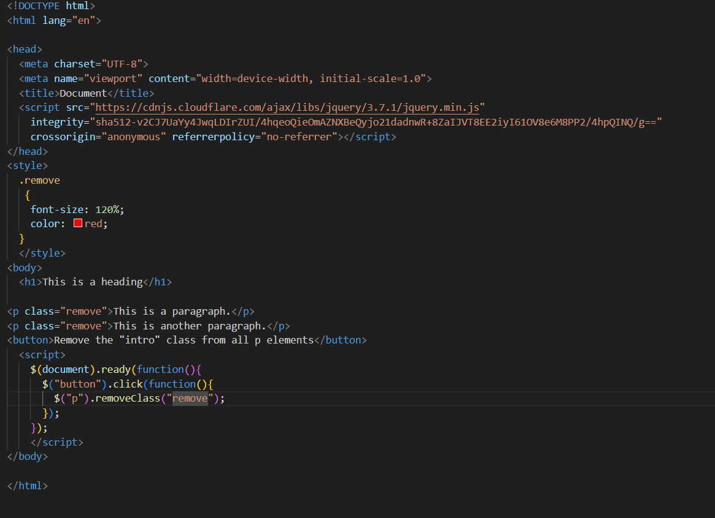

Output:

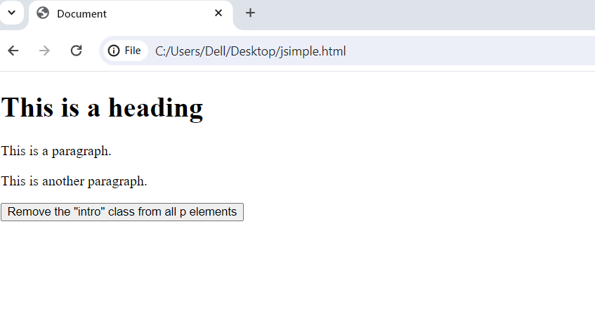

**jQuery Animation:**

The jQuery animate() method is used to create custom animations.

Syntax: $(*selector*).animate({*params*}*,speed,callback*);

The required params parameter defines the CSS properties to be animated.

The optional speed parameter specifies the duration of the effect. It can take the following values: "slow", "fast", or milliseconds.

The optional callback parameter is a function to be executed after the animation completes.

Example:

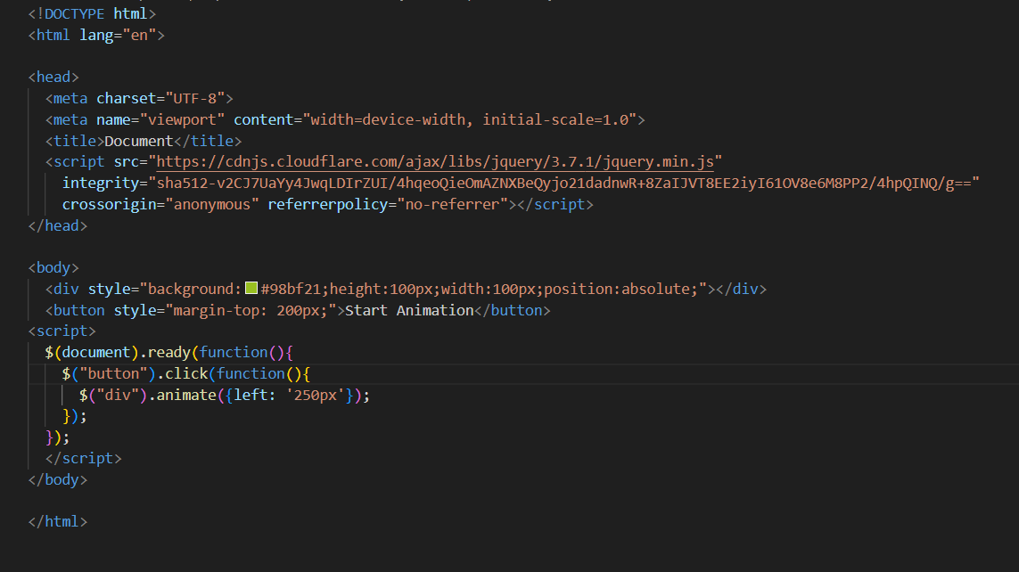

Output:

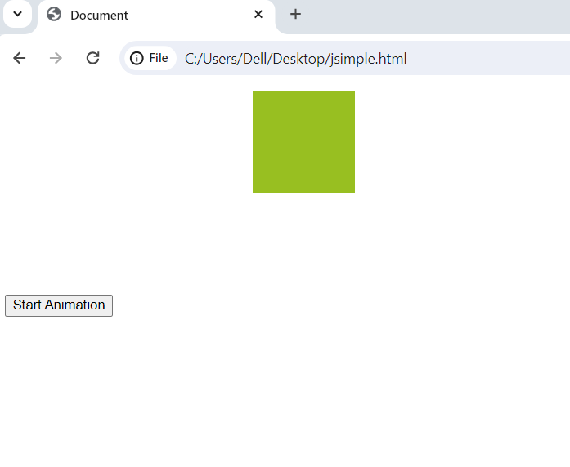

**Q-3. How to create slider with animation?**

**Ans: Example:**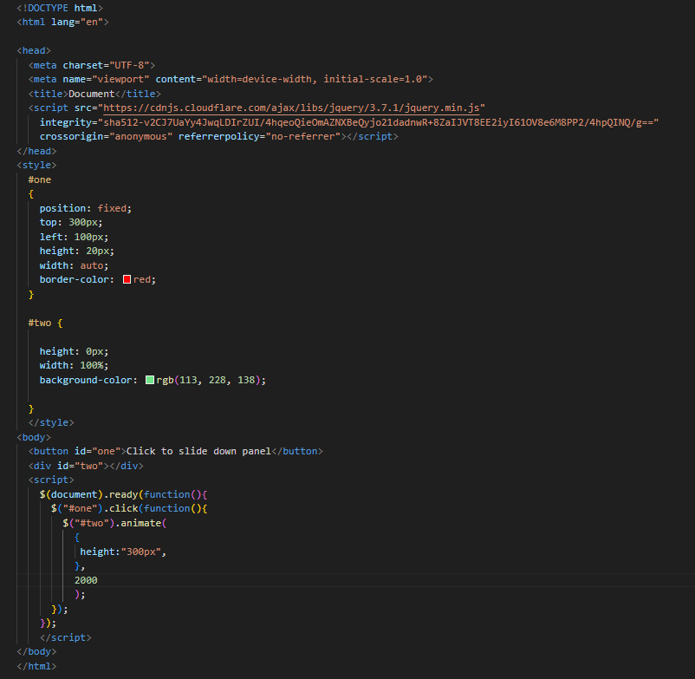

**Output:**

**Before click on button**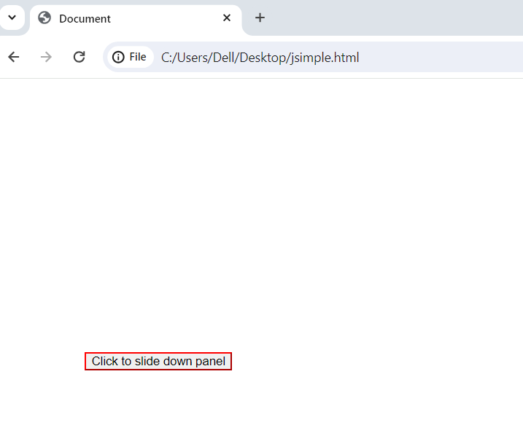

**After click on button**

